Metabolism Normal and Abnormal
Definition of the metabolism :
A Biochemical process in which chemical energy is transfer to biological energy to sustain life is called metabolism. It consist of following steps.
- Catabolism : Degradation of food stuff .
e.g. Proteins gives Amino Acids.
2. Anabolism : Formation of the new molecule.
e.g. Amino acids by polypeptide bonds forms proteins.
Carbohydrate Metabolism:

Glycolysis: Break down of glucose to pyruvate is known as Glycolysis.

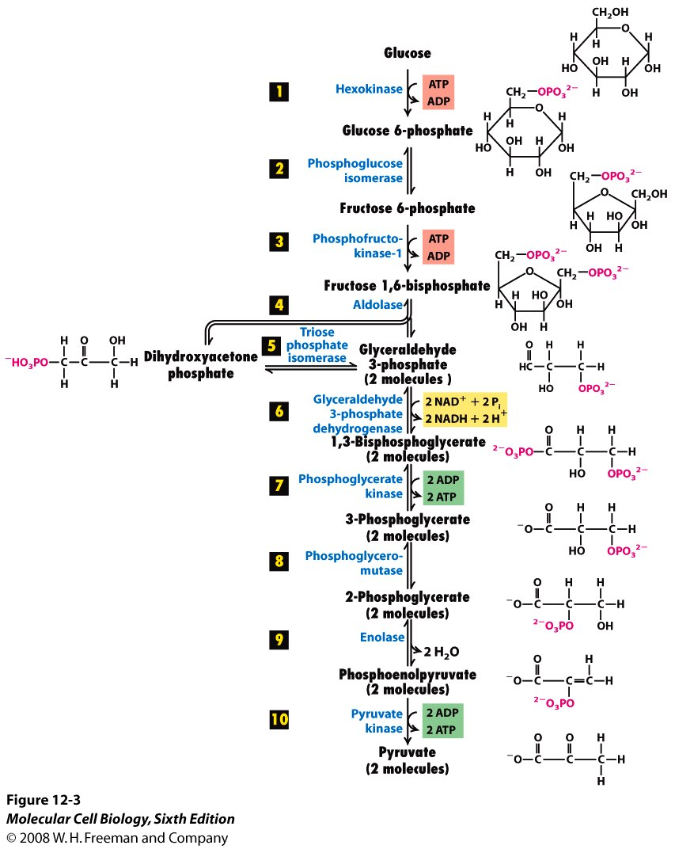
Glycolysis is the process of conversion of Glucose to pyruvate. And this pyruvate futher produces acetyl Co A which is transfer for the Citric Acid Cycle.

CITRIC ACID CYCLE

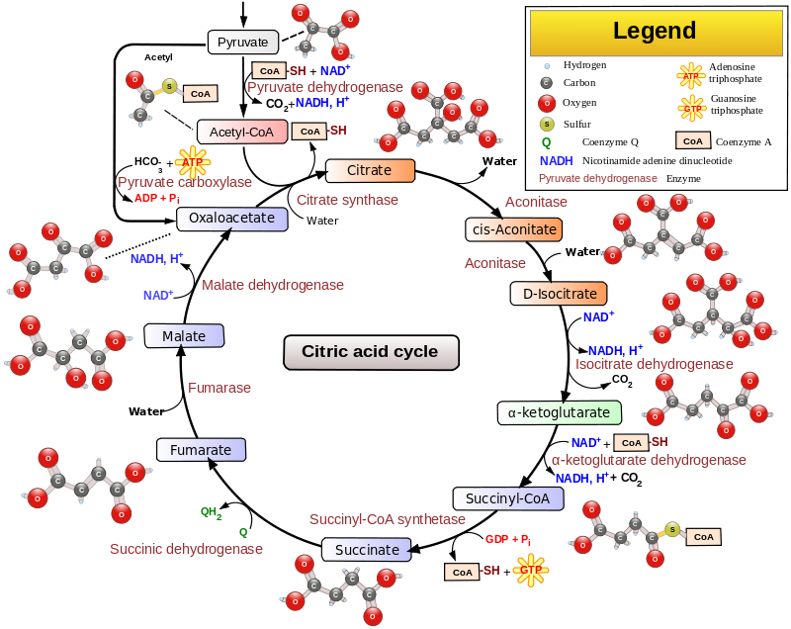

- As shown in Figure there are eight enzymic steps in the TCA cycle and details of the chemical reactions involved can be found elsewhere.
- The cycle begins with an irreversible aldol condensation reaction where the two-carbon acetyl group from acetyl-CoA is transferred to the four carbon dicarboxylic acid oxaloacetate, to form the six-carbon tricarboxylic acid citrate. This reaction is catalyzed by the enzyme citrate synthase.
- In the second reaction, citrate is converted to isocitrate in a two step process catalyzed by the enzyme acontinase. Here a water molecule is removed (dehydration reaction) from the citric acid forming the intermediate cis-aconitate which is then rehydrated to form isocitrate. The overall effect of this conversion is that the –OH group is moved from the 3' position (citrate) to the 4' position (isocitrate) of the molecule.
- In the third reaction, another two step process, the enzyme isocitrate dehydrogenase catalyzes the oxidation of the –OH group at the 4' position of isocitrate to yield a molecule of NADH + H⁺ and the tricarboxylic acid intermediate oxalosuccinate which is then decarboxylated to yield the α-ketoglutarate.
- This is another rate-limiting, irreversible stage in the cycle. In the fourth reaction, an oxidative decarboxylation catalyzed by the enzyme α-ketoglutarate dehydrogenase, the α-ketoglutarate is converted to succinyl-CoA.
- This involves the reduction of NAD⁺ to NADH + H⁺ and the production of succinyl-CoA.
- The fifth reaction of the TCA cycle is a succinyl-CoA synthetase In this reaction a free phosphate group attacks the succinyl-CoA molecule releasing the CoA (hydrolysis) and generating a succinate.
- In the sixth reaction succinate is oxidized to fumarate by the enzyme succinate dehydrogenase
- The last two (seventh and eighth) steps of the TCA cycle involve the hydration of fumarate to malate by the enzyme fumarase and the oxidation of malate to oxaloacetate by the enzyme malate dehydrogenase. Both of these reactions are readily reversible and a new molecule of oxaloacetate has been generated for the next round of the cycle.
- In summary, one round of the TCA cycle results in one molecule of acetyl-CoA being oxidized to two molecules of CO₂ with the generation of one molecule of GTP (step 5), three molecules of NADH + H⁺ (steps 3, 4 and 8) and one molecule of FADH₂ (step 6). The NADH + H⁺ and FADH₂ molecules act as electron carriers and are used to generate ATP in the process of oxidative phosphorylation. The carbons lost as CO₂ in the each turn of the TCA cycle originate from the oxaloacetate moiety, not the acetyl-CoA. The carbons donated by acetyl-CoA become part of the oxaloacetate carbon backbone used in the next turn of the cycle. Loss of the acetyl-CoA-donated carbons as CO₂ requires several turns of the citric acid cycle. The TCA cycle occurs in the mitochondrial matrix while the process of oxidative phosphorylation occurs at the inner mitochondrial membrane.
Protein Metabolism:
Proteins catabolism produces amino acids and amino acids by catabolism produces Ammonia and this ammonia is toxic to our body cells. This should be excrete from body this is happen by the urea cycle in this cycle the ammonia from amino acid metabolism converted into urea and this urea will be excrete trough kidneys from our body.
Catabolism of Amino acids takes place by following reactions.
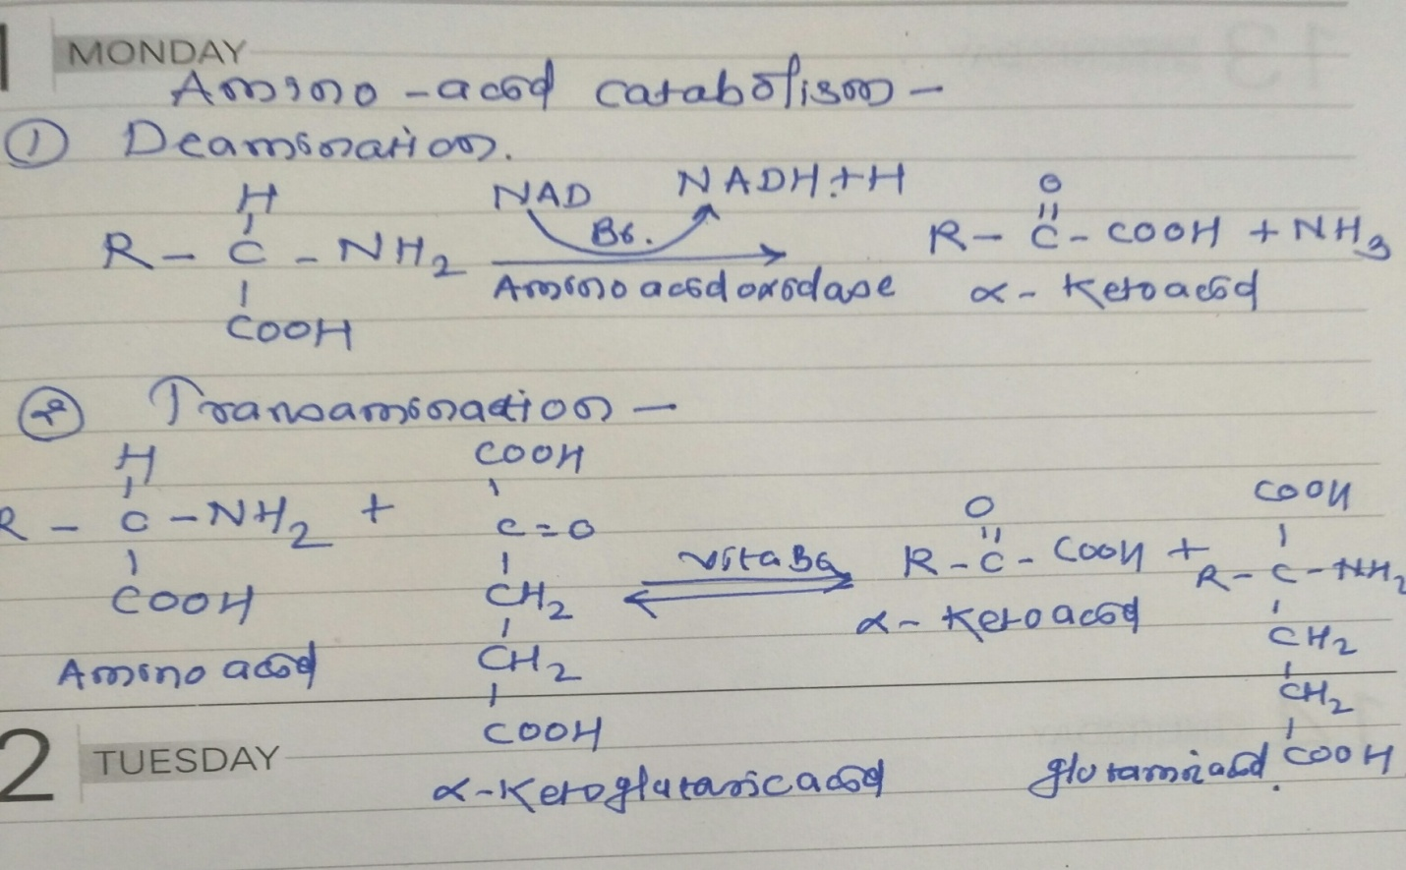

Urea Cycle:
- The urea cycle (also known as the ornithine cycle) is a cycle of biochemical reactions occurring in many animals that produces urea ((NH₂)₂CO) from ammonia (NH₃). This cycle was the first metabolic cycle discovered (Hans Krebs and Kurt Henseleit, 1932), five years before the discovery of the TCA cycle. In mammals, the urea cycle takes place primarily in the liver, and to a lesser extent in the kidney.

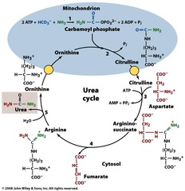
OR
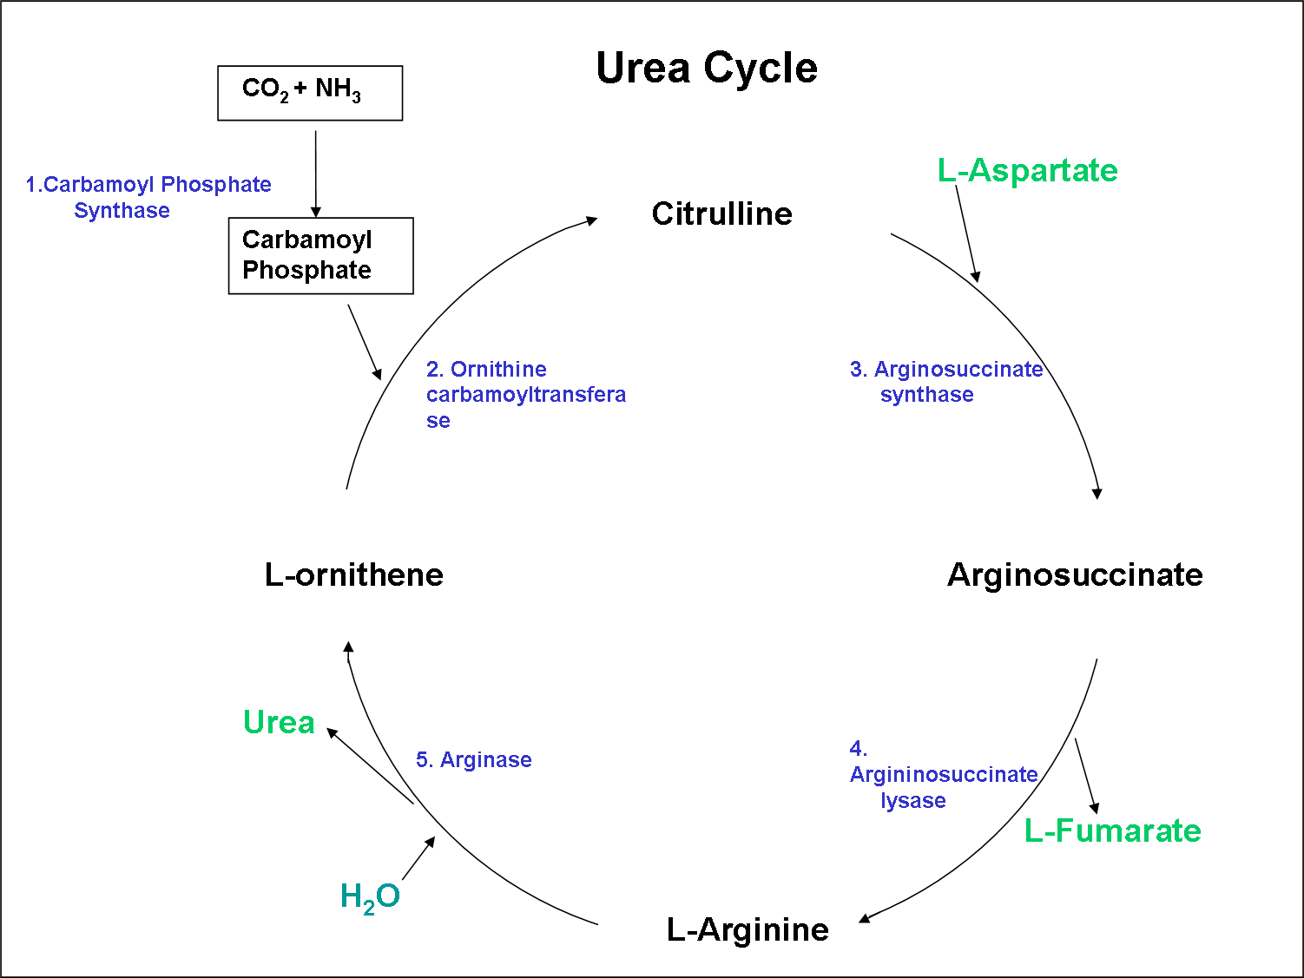

Metabolism of Fats or Lipids:
- What Is Beta-Oxidation?
Your body can make fatty acids or use fatty acids for energy. Your body makes fatty acids when energy needs are low and nutrients are abundant. When you need energy (as in cases of severe starvation, intense exercise, or stress), your body sends fatty acids to be broken down for energy. Beta-oxidation is the process by which fatty acids, specifically saturated fatty acids, are broken down for use in energy production.
- Steps in Beta Oxidation:
- So beta-oxidation is a good thing, right? It breaks down fatty acids. Imagine the process of beta-oxidation as a play. First, you need to know the setting, the stage if you will. Beta-oxidation most often takes place inside the mitochondrial matrix, although it can also occur in organelles called peroxisomes.
- There are four main steps—or acts—in beta-oxidation:
- Loss of hydrogens
- Addition of water
- Loss of another hydrogen
- Addition of another CoA

Beta Oxidation:
- 